<https://github.com/SidSahu2016/smart-doge>

tutorial code eater

<https://www.youtube.com/watch?v=Ag2C2Y622Bk&t=407s>

command: -

1. Create folder > open VS code
2. Npm init -y –don’t do it
3. Npx hardhat
4. npm install –-save-dev hardhat
5. create JavaScript project
6. create smart contract with NFTmint function
7. npm install dotenv –save
8. add API URL and Private key to it
9. install ethers.js
10. delete default contract provided by hardhat
11. edit the hardhat config.js - paste the file present in github
12. compile – npx hardhat compile
13. it will create an artifacts folder
14. create a script – deploy.js
15. npx hardhat run scripts/deploy.js –goerli // deploy it on testnet
16. till here the smart contract part is done . now the next part begins
17. npm install alchemy node.js web3.js library – npm install @alch/alchemy-web3 //open it in admin mode and then go to the project folder and do the installation
18. In scripts folder create mint-NFT.js file to define minting of the NFT.

get smart contract json file in it

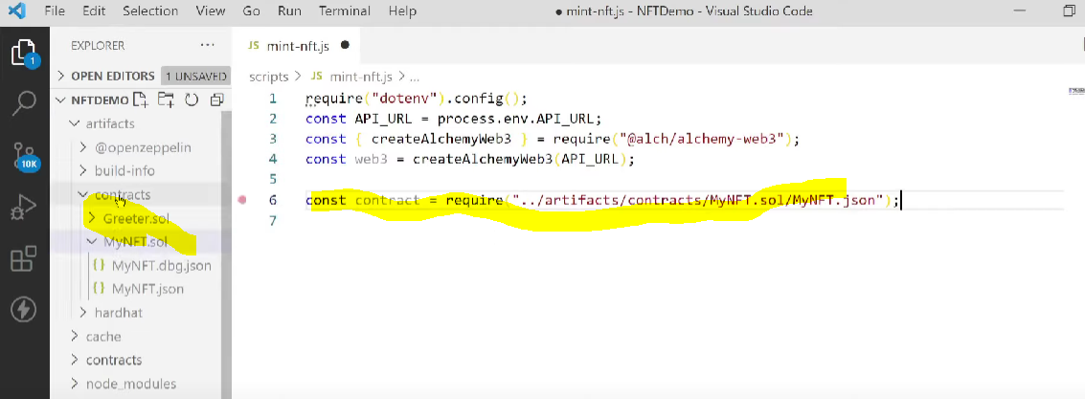

1. Node mint-NFT.js //to test if json file fetched correctly or not . it will return ABI and
2. Go to pinata website , create account , upload image and get the URL
3. Create nft-metadata.json in the main proj folder and past the metadata details along with the URL of image

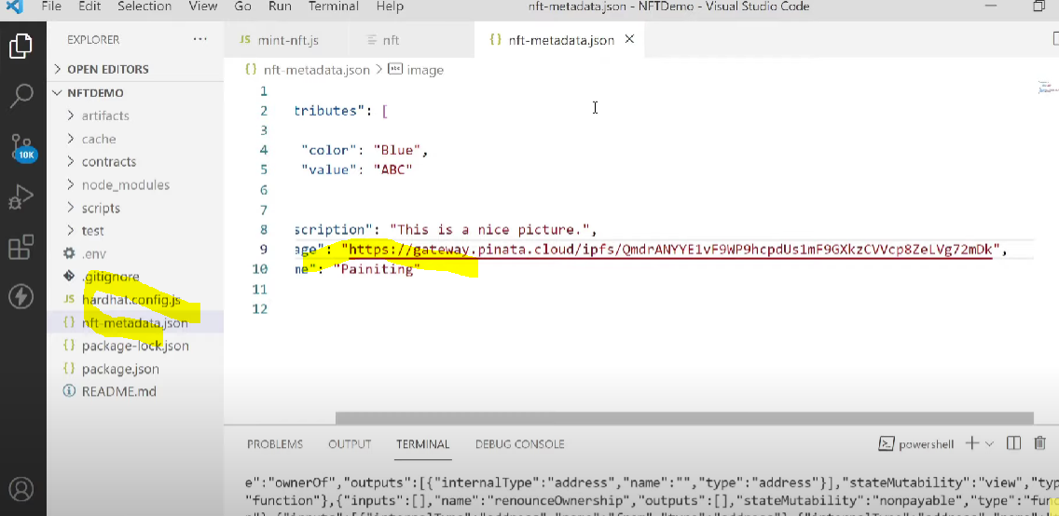

1. Upload this metadata file on Pinata
2. Go to nft-mint.js and add contractAddress and create an object for this
3. In .env file add your public KEY
4. In mint-nft.js add var for public and private keys
   1. AND create function to create nonce and tx
   2. Paste the code to sign the transaction
   3. At the last call mintNFT function in the end and as a parameter for TokenURI pass the metadata-NFT.json URL from the pinata
5. Recompile and then
6. Node scripts/mint-NFT.js
7. Import nft in your wallet with address and token id and then transfer
8. Repeat step 27 to create multiple nfts with different token ids

PINATA:-

[https://gateway.pinata.cloud/ipfs/QmQdF8VMrG6offFTzjsEMVvfWmAvB878qZteCUTEyjC1JU?_gl=1*nyf5nf*_ga*OTYzMzU4MjM2LjE2NzY0NzEyMDg.*_ga_5RMPXG14TE*MTY3NjQ3MTIwOC4xLjEuMTY3NjQ3MTI3NC41Ny4wLjA](https://gateway.pinata.cloud/ipfs/QmQdF8VMrG6offFTzjsEMVvfWmAvB878qZteCUTEyjC1JU?_gl=1*nyf5nf*_ga*OTYzMzU4MjM2LjE2NzY0NzEyMDg.*_ga_5RMPXG14TE*MTY3NjQ3MTIwOC4xLjEuMTY3NjQ3MTI3NC41Ny4wLjA).

https://gateway.pinata.cloud/ipfs/QmQdF8VMrG6offFTzjsEMVvfWmAvB878qZteCUTEyjC1JU?_gl=1*mmgzgj*_ga*NTM3NTYzNjIuMTY3NjY0MzI0Mw..*_ga_5RMPXG14TE*MTY3NjY0MzI0My4xLjEuMTY3NjY0MzI3NC4yOS4wLjA.